

ADF&G Cohort Analysis System
Phase 2 – CFile Generation

Software Design Specification

4/19/02

Submitted by

Wostmann & Associates, Inc.
Change Control

The following information is being used to control and track modifications made to this document.

1) Revision Date: 6/3/02
Author: Rick Busch
Section(s): 6.2
Page Number(s):
Summary of Change(s): Updated Release File Format to reflect new CWDB format for mark types and counts and to specify (three character) Stock Code instead of Stock Site. Removed ReleasedWithCWT, ShedCWT, ReleasedWithoutCWT from WireTagCode and replaced with CWTMark1, CWTMark1Count, CWTMark2, CWTMark2Count, NonCWTMark1, NonCWTMark1Count, NonCWTMark2, NonCWTMark2Count.

2) Revision Date: 6/6/02
Author: Rick Busch
Section(s): 6.2
Page Number(s):
Summary of Change(s): Updated Catch Sample File Format to reflect new CWDB format. Replaced last 3 fields in CWDBCatchSample table corresponding columns: PartitionSize1, SampleSize1, KnownAdStatus1, ObservedAdClips1, PartitionSize2, SampleSize2, KnownAdStatus2, ObserveredAdClips2. Updated CA

3) Revision Date: 6/19/02
Author: Rick Busch
Section(s): 4.3.1, 4.3.2 (deleted), 6.3 (deleted), 7.1, 7.2, 7.3, A.9
Page Number(s): 14, 31, 35, 36, 46
Summary of Change(s): Removed requirement to load and store Release Augmentation information. Revised Test Cases 1, 2, and 3. Added CatchSiteStateProvince, CatchSiteArea, CatchSiteRegion to CWDBCatchSample table to support CalculateExpansionFactors.

4) Revision Date: 6/19/02
Author: Rick Busch
Section(s): 4.3.2, 4.4, A4
Page Number(s): 15, 22, 23, 42
Summary of Change(s): Refined requirements for calculating expansion factors based on new information from ADF&G regarding the definition of strata based on Area and calendar or accounting year. Added CatchSiteStateProvince, CatchSiteArea, CatchSiteRegion to CWDBCatchSample table to support CalculateExpansionFactors.

5) Revision Date: 6/20/02
Author: Rick Busch
Section(s): 6.1, A.3, A.5
Page Number(s): 29, 41, 43
Summary of Change(s): Added LengthCode to CWDBRecovery table, CWDB Recovery File Format, and added related LengthMeasurementMethod lookup table.

6) Revision Date: 6/26/02
Author: Rick Busch
Section(s): 4.3.4, 4.4, A.2, A.7, A.8, A.11
Page Number(s): 20, 23, 40, 45, 46, 49
Summary of Change(s): Updated logic for specifying and loading Auxiliary data. Added CFileFisheryRecovery table, analogous to FisheryRecovery table, but necessary to support generation of old CFiles. Added Jurisdiction to SpeciesStock. Added Expansion meta-data tables to support CalculateExpansionFactors.
7) Revision Date: 7/3/02
Author: Rick Busch
Section(s): 4.3.2. 4.3.3
Page Number(s): 15, 19
Summary of Change(s): Added generation of Ids for Catch Sample records that are missing Ids, and generation of matching Catch Sample Ids on Recovery records.
8) Revision Date: 7/5/02
Author: Rick Busch
Section(s): 4.4
Page Number(s): 23
Summary of Change(s): Changed area grouping for expansions on Troll Catch Samples to be all areas instead of by SE AK Quadrant

9) Revision Date: 8/8/02
Author: Rick Busch
Section(s): 4.3.3.1, 4.6, A.4, A.5, A.6
Page Number(s): 22, 29, 44, 45, 46
Summary of Change(s): Updated data model. Added Agency to CWDBRecovery and CWDBCatchSample, PK of CWDBRecovery changed to include Agency and RunYear, PK of CWDBCatchSample changed to include Agency and CatchYear. Added StartMonth, StartDay, EndMonth, EndDay to FisheryLookup. Updated FisheryLookup logic to handle split Month and Day columns correctly. Updated logic for Export CFile to coerce recoveries with age > MaxAge down to MaxAge.
10) Revision Date: 8/12/02
Author: Rick Busch
Section(s): 6.1, 6.3
Page Number(s): 33, 35
Summary of Change(s): Added Agency to file formats for Catch Sample and Recovery data.
11) Revision Date: 8/13/02
Author: Rick Busch
Section(s): 4.3.3
Page Number(s): 20
Summary of Change(s): Update validation on Load Recovery. Throw out if SampleType = 5, Voluntary Sport = Sample Type 3 or 4, CWDBFishery 40-49.

12) Revision Date: 8/15/02
Author: Rick Busch
Section(s): 4.6
Page Number(s): 28-9
Summary of Change(s): Added user-specification of Last Run Year to requirements for Exporting CFiles. Updated specification to state that the maximum number of recovery count rows in CFiles is determined by MaxAge (not fixed to 6). Updated specification to state that LastRunYear – BroodYear OR MaxAge, whichever is less, is written to line 5 of the CFile, (not always MaxAge)
13) Revision Date: 8/28/02
Author: Rick Busch
Section(s): 4.5, 4.6
Page Number(s): 28, 30
Summary of Change(s): Updated Generate Recovery Counts to note that Recoveries will only use the Expansion Factor on related Catch Sample records if both records also have the same CWDB Fishery code. Updated Export CFiles to say the EstimatedRecoveries (not RecoveryCounts) are summarized for output to the CFiles.
14) Revision Date: 9/6/02
Author: Rick Busch
Section(s): 4.3.3, 4.5
Page Number(s): 22, 28
Summary of Change(s): Updated Load Recovery logic to NOT throw out recoveries with Null or Zero Estimated Numbers IF SampleType = 1. Updated Calculate Estimated Recoveries to round Estimated Numbers to between 1 and 50. (Do not change original value to between 1 and 50 when loading the Recoveries).
15) Revision Date: 9/17/02
Author: Rick Busch
Section(s): 4.3.3, 4.5, Data Model Diagrams
Page Number(s): 21, 22, 29
Summary of Change(s): Updated Fishery definition to include Terminal attribute. Changed logic in CalculateEstimatedRecoveries to NOT use Expansion Factor (even if there is one) for Recoveries in Terminal areas. Added Adjusted Estimated Number to Recovery and changed logic in Calculate Estimated Recoveries to use Adjusted Estimated Number instead of rounding to between 1 and 50 (as shown in previous change above). Removed rule that CWDBFishery code must match on both Recovery and its related Catch Sample record in order to apply the Expansion (undo change 13 above). This rule was a work-around to problem where data has incorrect Catch Samples associated with Recoveries that shouldn’t be expanded because they are Terminal (solved by new rule described in second sentence above).

Table of Contents
1 Overview 7
2 Development Environment 8
3 Development Standards 9
3.1 Code Architecture 9
3.2 Database Standards 10
3.2.1 Naming Conventions 10
3.3 Security Model 11
4 Functional Hierarchy 12
4.1 Populate Code Tables 12
4.2 Load Historical and Support Data 13
4.2.1 Load SpeciesStock Table 13
4.2.2 Load CFileFishery Table 13
4.2.3 Load Jurisdiction Table 13
4.2.4 Load JurisdictionCFileFishery Table 13
4.2.5 Load Fishery Table 13
4.2.6 Load FisheryLookup Table 13
4.2.7 Load FisheryCFileFishery Table 13
4.2.8 Load AKTrollSportChinookCatch Table 14
4.3 Load Raw Data 14
4.3.1 Load CWDB Release File 14
4.3.1.1 Calculate Natural Mortality Rate 15
4.3.1.2 Calculate Interdam Loss Factor 15
4.3.2 Load CWDB Catch Sample File 15
4.3.2.1 Validate Sampling Period Number 17
4.3.2.2 Validate Sampling Period Range 18
4.3.2.3 Validate Number Caught 18
4.3.2.4 Validate Number Sampled 19
4.3.3 Load CWDB Recovery File 19
4.3.3.1 Lookup Fishery 21
4.3.3.2 Calculate Age 22
4.3.3.3 Extrapolate Sport Recovery 23
4.3.4 Load Hatchery Escapement and Historical Catch Data File 24
4.4 Calculate Expansion Factors 24
4.5 Generate Fishery Recoveries 26
4.6 Export CFiles 27
4.7 Log Errors 29
4.8 Maintain Data 29
5 User Interface 30
6 File Formats 31
6.1 CWDB Recovery File 31
6.2 CWDB Release File 33
6.3 CWDB Catch-Sample File 34
6.4 CFile 36
7 Test Cases 38
7.1 Lookup Fishery 38
7.2 Load Release File 38
7.3 Load Recovery, Catch Sample, and Auxiliary Data 39
7.4 Generate Recoveries and Export CFiles 39
7.5 Final Acceptance Test 40

Overview
This document constitutes the design specification for the software deliverable of Phase 2 of the Cohort Analysis System (CAS) project. The purpose of this phase is to produce a program and an associated database to process and store annual release and recovery data from the Coastwide Database, and to generate CFiles used as input to the existing Cohort Analysis System.
The first two sections of this document specify the development software and database platform that will be used to implement the application. They also outline the overall software architecture and general development standards that will govern the development effort.
The Functional Hierarchy section includes a detailed functional breakdown outlining the scope of this phase of the application development. This section constitutes the specification for the Business Layer of the application and includes a detailed description of the business logic and computational algorithms behind each functional requirement of the application.
The User Interface section of this document describes the user interfaces that will need to be developed in order to satisfy the functional requirements. The functional requirements of the forms are described, including any constraints, validations, or other algorithms that need to be implemented.
The Test Cases section describes the test data and specific procedures that will be performed to verify correct performance of the system. This section also specifies the allocation of responsibilities associated with system testing between the contracting agency (WAI) and the client organization (ADF&G).
The file formats of all data files that will be used as program input are defined in the File Formats section.
Finally, a detailed data model is included in the Appendix. The data model section consists of a collection of Entity Relationship Diagrams that completely specify all table structures and data elements required to support the data storage, calculation, and system auditing requirements of the application.

Development Environment
The user interface(s) and business objects for Phase 2 of the CAS project will be implemented using Microsoft Visual Basic version 7 (VB.NET). For Phase 2 of the CAS project, the database platform will be Microsoft Access version 9 (Access 2000). Recipients of the system will be required to own appropriate licenses for MS Access 2000 in order to administer the database portion of the application.
The software will be designed to ensure that no business logic will be implemented in the database. The database will primarily contain the data storage structures, tables, and absolute minimal use will be made of other database objects such as queries, views, triggers, procedures, macros, etc. This design standard will facilitate the porting of the application to more robust database platforms, such as SQL Server or Oracle, should this be deemed appropriate in future development phases.

Development Standards

Code Architecture
The code architecture for this application will follow standard, n-tier application design standards indicating the following, clearly delineated application layers:
- Presentation Layer
- Business Layer
- Data Layer
The following guidelines will govern the organization of code in the application:
- All business layer functionality will be organized into class modules that can be compiled into stand-alone assemblies.
- The business layer object(s) will not contain any visual, user interface components.
- Error (or other) messages generated in the business layer, which need to be displayed to the user, will be raised as events to the presentation layer for visual display.
- The business layer will not contain embedded SQL statements or make direct calls to the database. All requests for data will be made through data layer methods.
- The presentation layer will consist of forms that can be compiled into a stand-alone executable.
- The presentation layer will contain logic concerned only with the display of information graphically to the screen, the format validation of user-input, and the marshalling of user-entered information to the business layer. No business logic will be implemented in any form modules or event handlers.
- The presentation layer will not contain embedded SQL statements or make direct calls to the database. All requests for data will be made through data layer methods.
- The data layer will only consist of logic concerned with inserting, update, deleting, or selecting data from the database. No business logic will be embedded in any data layer functions.
- The data layer will not contain any visual user-interface components.
The above guidelines represent standard practices for the development of n-tier applications. In addition to these general standards, the following specific guidelines will apply to this development effort:
- The data layer will be developed in Visual Basic (VB) as a collection of classes that can be compiled into a stand-alone assembly. The classes will generally correspond one-to-one to the data structures in the database.
- The data layer will also contain a generic data-access component implementing basic database connection and data retrieval functionality using ADO or DAO, as appropriate.
- All calls to the database from the data layer classes will pass through the generic data-access component. There will be no direct creation or use of technology-specific (ADO/DAO) objects in the other data layer classes.
This strategy (as opposed to implementing the data layer in the database itself, or embedding technology-specific objects in the data layer classes) will allow the system to be easily ported to different database platforms. Multiple versions of the generic data-access component can be developed for different data-access technologies (DAO, ADO, etc.) and compiled into the application as necessary.

Database Standards

Naming Conventions
The following naming conventions will be followed when developing database structures:
Table Names:
Initial caps on word boundaries, no underscores, e.g. ‘SpeciesStock’
Column Names:
Initial caps on word boundaries, no underscores or spaces, e.g. ‘WaterType’
Special Column Types:
‘Code’ will be used to represent an alphanumeric (varchar) code used to identify an entity.
‘ID’ will be used to represent a numeric (integer) value, generally system-generated that is used to identify an entity.
Columns implementing foreign keys to one of the above types of columns in another table will be named: <table name><column name>, e.g. ‘SpeciesCode’ in the ‘Fishery’ table represents a column that corresponds to the ‘Code’ column in the ‘Species’ table.

Security Model
For this phase of the project, all users will have access to all functions in the user interface. The user interface application will use an internal login to connect to the database that has permissions to all objects in the database.
Some data may need to be modified directly in the database using the MS Access environment. For this phase of the project, no security will be enforced. Any user will be able to open the database file in MS Access as the default Admin user and have the ability to insert, update, or delete data in all tables in the database.
In later phases, a more granular security model will be defined and implemented in whatever database platform is used to implement future phases of the application. At this time, the following general security groupings have been identified:
- System Administrators (full access, ability to define users)
- Data Loaders (Ability to insert updates into the raw data tables)
- Data Analyzers (Ability to update data in configuration or scenario tables)
- Analysis Consumers (Read-only access to all data)

Functional Hierarchy

Populate Code Tables
System setup requires the population of the following code lookup tables:
Species
StockBrood
SpeciesStock
StockName
GearType
Run
CWDBFishery
TagType
TagStatus
EstimationLevel
SampleType
SamplingPeriodType
MarkType
LengthMeasurementMethod
StateProvince
Sector
Region
Area
Location
SubLocation
These tables contain static information solely used to validate coded values appearing in the raw CWDB data or manually entered into the system. This is a one-time operation performed at setup time. It will be facilitated by the use of an MS Excel workbook (StaticData.xls) that contains values for these tables entered by the client.

Load Historical and Support Data

Load SpeciesStock Table
The Species Stock table will be loaded via a batch insert statement generated from values manually entered by the client in StaticData.xls.

Load CFileFishery Table
The CfileFishery table will be loaded via a batch insert statement generated from values manually entered by the client in StaticData.xls.

Load Jurisdiction Table
The Jurisdiction table will be loaded via a batch insert statement generated from values manually entered by the client in StaticData.xls.

Load JurisdictionCFileFishery Table
The JurisdictionCFileFishery table will be loaded via a batch insert statement generated from values manually entered by the client in StaticData.xls.

Load Fishery Table
The Fishery table will be loaded via a batch insert statement generated from values manually entered by the client in StaticData.xls.

Load FisheryLookup Table
The FisheryLookup table will be loaded via a batch insert statement generated from values manually entered by the client in StaticData.xls.

Load FisheryCFileFishery Table
The FisheryCFileFishery table will be loaded via a batch insert statement generated from values manually entered by the client in StaticData.xls.

Load AKTrollSportChinookCatch Table
The AKTrollSportChinookCatch table will be loaded via a batch insert statement generated from values manually entered by the client in StaticData.xls.

Load Raw Data

Load CWDB Release File
The StockBrood table parents the WireTagCode table. That is, for every row in StockBrood, there will be one or more rows in WireTagCode associated by a foreign key. Both tables are populated from data in the CWDB Release File. Every row of data in the release file represents a WireTagCode record. Before inserting the WireTagCode record, however, the system must determine if a corresponding StockBrood record exists, and if not, create one. The logic for processing the CWDB release file is as follows:
- Specify location of CWDB Release File.
- Open and begin reading CWDB Release File.
- For each row:
  - Lookup StockBrood record for Species, Stock Code, and BroodYear values of current row.
  - If no record found then:
    - Insert new record in StockBrood for with primary key values of Species, Stock, and BroodYear from current row.
    - Set Natural Mortality Rate columns as described in Calculate Natural Mortality Rate.
    - Set Interdam Loss Rate columns as described in Calculate Interdam Loss Rate. (All NULL in this phase)
  - Insert new record in the WireTagCode table copying values from data file row to corresponding columns in the table.
    - FK constraints or validation routines will validate codes before insert, generate .bad file with failed rows for subsequent research, and then revise input file if necessary.
    - The following specific validations will be performed:
      - Duplicate Wire Tag Code (PK)
      - Valid Species Code (FK)
      - Brood Year between 1971 and Year(Today)
      - NumberWithCWT > 0
      - NumberShedCWT = Null OR >= 0
      - NumberWithoutCWT >= 0
- Close file.

Calculate Natural Mortality Rate
In the current system and for this phase of the project, the Natural Mortality Rates by Age for all Stock Broods will be set to constants as follows:
Age 1 = 0
Age 2 = .4
Age 3 = .3
Age 4 = .2
Age 5 = .1
Age 6 = .1
Age 7 = .1
These values are not used during CFile creation. The logic for calculating these values in the future is outside the scope of this phase.

Calculate Interdam Loss Factor
For this phase of the project, the Interdam Loss Factor for all ages will be set to NULL. These values are not used during CFile creation. These values will be updated manually or via a batch process in the future. The mechanism for updating these values is outside the scope of this phase.

Load CWDB Catch Sample File
The CWDB Catch Sample file will be loaded directly into the CWDBCatchSample table. Each row in the data file corresponds one-to-one to a record in the table. Only Alaska uses catch sample data in the CFile generation process.
The Catch Sample data file format includes an agency-specific Id. This Id is used to associate Recovery records with Catch Sample records. (CatchSampleId field of Recovery data file) However, many Catch Sample records currently do not have an Id. “0” appears instead in the Catch Sample Id field. This data will be updated with appropriate Ids in the future. For this project, if a Catch Sample record is found with “0” for the Id, an Id will be constructed from the following data values on the Catch Sample record, which should uniquely identify a Catch Sample:
- Catch Year (last two digits)
- CWDB Fishery Code
- Sampling Period (left-padded with zeros to 2 chars)
- Catch Site (Region and Area portion)
Example: 761001NE101
After Catch Sample data has been loaded, and Ids constructed for those records missing Ids, the Catch Sample rows with constructed Ids must be associated with their appropriate Recovery records. See Load CWDB Recovery File.
NOTE: Handling of “0” Catch Sample Ids as described above is a temporary work-around incomplete data. Catch Sample and Recovery data will eventually be resubmitted so that no records have “0” ids.
The following steps outline the logic for processing the Catch Sample file.
- Specify location of CWDB Catch Sample File.
- Open and begin reading CWDB Catch Sample File.
- For each row:
  - Insert new record in CWDBCatchSample.
    - Lookup the Fishery according to logic described in Lookup Fishery.
    - Set the CatchSiteStateProvince, CatchSiteArea, and CatchSiteRegion fields based on values parsed from the Catch Site code. (see Lookup Fishery for logic to parse the site code)
    - Set Expansion Factor = NULL (populated later according to Calculate Expansion Factors).
    - Perform following validations:
      - Species code (FK)
      - CWDB Fishery Code (FK)
      - Sample Type (FK)
      - Sampling Period Type (FK)
      - Sampling Period Number (Validate Sampling Period Number)
      - First Sampling Period (Validate Sampling Period Range)
      - Last Sampling Period (Validate Sampling Period Range)
      - Number Caught (Validate Number Caught)
      - Number Sampled (Validate Number Sampled)
      - All Tag counts and Lost Heads must be <= Number Sampled (if not NULL)
      - Estimation Level (FK) (must be present if Estimated Number not NULL)
      - Detection Method (check constraint: ‘E’ or ‘V’)
- Close file.

Validate Sampling Period Number
The Sampling Period Number is validated relative to the value of the Sampling Period as follows:
Sampling Period | Description | Allowable Sampling Period Number
1 | Escapement | 01
2 | Bi-weekly | 01-26
3 | Semi-monthly | 01-24
4 | Statistical Month | 01-12
5 | Calendar Month | 01-12
6 | Statistical Week | 01-54
7 | Week | 01-54
8 | Seasonal | 01-04
10 | Weekend | 01-54
11 | Weekday | 01-54

Validate Sampling Period Range
If the Catch Sample is for any gear but Troll, the Sampling Period Number will represent the correct Sampling Period. For Troll, however, the Sampling Period Number will represent a span of Statistical Weeks (which varies from year to year), and First Sampling Period and Last Sampling Period will represent the beginning and ending Statistical Week within the sampling period range.
Therefore, if the First Sampling Period is not Null, then the Last Sampling Period cannot be Null. The First Sampling Period must be between 1-54 and must be less than the Last Sampling Period.
If the Last Sampling Period is not Null, the First Sampling Period cannot be Null. The Last Sampling Period must be between 1-54 and must be greater than First Sampling Period.
NOTE: For this phase, Sampling Periods are not used during any calculations. They will be used in future phases to calculate Expansion Factors on time periods that are less than a calendar year.

Validate Number Caught
Required if Number Sampled is NULL and Sample Type = 1.
Must be NULL if Sample Type of related Recovery Records = 4 and Catch is unknown.
May be NULL if Sample Type of related Recovery Records = 3.
Implementation Note: These rules are from the PSMFC data file definition document for submission of data to the CWDB. It is not necessary to perform this validation for this phase of the project.

Validate Number Sampled
Required if Number Caught is NULL and Sample Type = 1.
If present, must be >= Recovered Tags + Missing Tags + Lost Tags + Unreadable Tags + Unresolved Tags + Lost Heads + Not Tagged.

Load CWDB Recovery File
The CWDB Recovery file will be loaded directly into the CWDBRecovery table. Each row in the data file corresponds one-to-one to a record in the table.
Each CWDB Recovery record has a Catch Sample Id field. In some cases, this field will have a value, but its value will not correspond to any Catch Sample records loaded. So, its validation cannot be enforced with a foreign key.
In other cases, the recovery record will not have a Catch Sample Id specified, but one will need to be generated to potentially match an Id generated for a Catch Sample record with a “0” Id during the loading of the Catch Sample data. If a recovery record does not have a Catch Sample Id, one will be generated as follows:
- Year(RecoveryDate) (last two digits)
- CWDB Fishery Code
- Sampling Period (left-padded with zeros to 2 chars)
- Recovery Site (Region and Area portion)
Example: 761001NE101
If the generated Id corresponds to an actual Catch Sample record, it will be saved with the Recovery. Otherwise the Catch Sample Id field will be left null. Catch Sample Ids will NOT be generated for Auxiliary or Extrapolated Recoveries or for Recoveries in Terminal Fisheries.
NOTE: Handling of “0” Catch Sample Ids as described above is a temporary work-around incomplete data. Catch Sample and Recovery data will eventually be resubmitted so that no records have “0” ids.
The following is the logic for processing the CWDB Recovery file.
      - Specify location of CWDB Recovery File.
      - Open and begin reading CWDB Recovery File.
      - For each row:
    - Insert new record in CWDBRecovery.
    - Lookup the Fishery ID according to logic described in Lookup Fishery.
    - If unable to lookup a CFile Fishery (such as incomplete location information), then skip row. The skipped row will be written to a .bad file so that missing rows can be researched.
    - Calculate the Age of the recovered fish (Calculate Age).
    - Perform following validations:
      - Species code (FK)
      - CWDB Fishery Code (FK)
      - Sex (check constraint: ‘M’, ‘F’, ‘U’)
      - Tag Status (FK)
      - Tag Code (FK)
      - Detection Method (check constraint: ‘E’, ‘V’)
      - Recorded Mark (FK)
      - Sample Type (FK). Can’t be “5”
      - Sampling Period Type (FK)
      - Sampling Period Number (Validate Sampling Period Number)
      - Estimation Level (FK)
      - Catch Sample ID present (required if SampleType = 1,2,4,6) Attempt to generate if not present.
      - Calculate AdjustedEstimatedNumber: If Estimated Number is Null, and CWDB Fishery Code represents a Sport Fishery (40-49) and Sample Type represents Voluntary (3 or 4), then set Adjusted Estimated Number to 4, otherwise if Estimated Number is Null and SampleType = 1 then set Adjusted Estimated Number = 0, otherwise if Estimated Number is Null or zero, ignore (throw out) the record. If Estimated Number is > 50, then set Adjusted Estimated Number = 50.
    - If applicable, insert an extrapolated Sport Recovery record (Extrapolate Sport Recovery)
4. Close file.

Lookup Fishery
To lookup a Fishery from a CWDB Recovery or a CWDB Catch Sample data row:
- Parse the Recovery Site Code as follows:
  - Char(1) = StateProvince
  - Char(2) = WaterType
  - Char(3) = Sector
  - Char(4-6) = Region
  - Char(7-9) = Area
  - Char(10-16) = Location
  - Char(17-19) = Sub-Location
- Lookup the Stock from the related WireTagCode record. Catch Sample records do not have related WireTagCode records. Stock will never matter when determining the Fishery for a Catch Sample.
- Select Fishery from the FisheryLookup table where:
  - FisheryLookup.CWDBFishery = CWDBRecovery.CWDBFishery
  - FisheryLookup.StateProvince = StateProvince
  - FisheryLookup.WaterType is NULL or FisheryLookup.WaterType = WaterType
  - FisheryLookup.Species = CWDBRecovery.Species
  - FisheryLookup.Sector is NULL or FisheryLookup.Sector = Sector
  - FisheryLookup.Region is NULL or FisheryLookup.Region = Region
  - FisheryLookup.Area is NULL or FisheryLookup.Area = Area
  - FisheryLookup.Location is NULL or FisheryLookup. Location = Location
  - FisheryLookup.SubLocation is NULL or FisheryLookup. SubLocation = SubLocation
  - FisheryLookup.Stock is NULL or FisheryLookup.Stock = Stock
  - (FisheryLookup.StartMonth is NULL and FisheryLookup.StartDay is Null) or (FisheryLookup. StartMonth < Month(CWDBRecovery.RecoveryDate)) or (FisheryLookup.StartMonth = Month(CWDBRecovery.RecoveryDate) and FisheryLookup.StartDay <= Day(CWDBRecovery.RecoveryDate))
  - (FisheryLookup.EndMonth is NULL and FisheryLookup.EndDay is Null) or (FisheryLookup. EndMonth > Month(CWDBRecovery.RecoveryDate)) or (FisheryLookup.EndMonth = Month(CWDBRecovery.RecoveryDate) and FisheryLookup.EndDay >= Day(CWDBRecovery.RecoveryDate))

Calculate Age
The age of a recovered fish is generally equal to the RunYear minus the BroodYear (from related WireTagCode record). Some Fisheries age recovered fish an additional year if the fish is recovered after some given day of the year. This date is represented by the AgeIncrementMonthDay column of the Fishery table. The decision to age fish an additional year applies only to recoveries that were made after the initial year in which the practice came into use. The year after which the aging rule applies, when applicable, is represented by the AgeIncrementStartYear column.
Age = CWDBRecovery.RunYear – WireTagCode.BroodYear
If Fishery.AgeIncrementStartYear is not NULL AND
Fishery.AgeIncrementMonthDay is not NULL AND
CWDBRecovery.RunYear >= Fishery.AgeIncrementStartYear AND
MonthDay(CWDBRecovery.RecoveryDate) >= Fishery.AgeIncrementMonthDay Then
Age = Age + 1
End If
There are rare exceptions to this rule. For example, in Canada, Troll recoveries in regions 01, 02 are aged an additional year beginning in 1998 for recoveries on or after Oct. 1, EXCEPT if the Stock of the recovered fish is Robertson Creek Hatchery and the computed age is 4 or 5.
The AgeException table represents these exceptions to aging rules. Records in this table represent a Fishery, Species and Stock to which the exception applies. The presence of a record in this table implies that the Fishery of the record has values for AgeIncrementStartYear and AgeIncrementMonthDay specifying an aging rule.
The ExceptionAge value of the AgeException record represents the pre-adjusted age of the fish, after which the exception will be applied.
Example:
    - A recovered fish is determined to be in a Fishery that has an aging rule defined. (values defined for the AgeIncrementStartYear and AgeIncrementMonthDay columns of the Fishery)
    - The Recovery Date of the fish is after the AgeIncrementStartYear and AgeIncrementMonthDay for the Fishery
    - The recovered fish is also determined (from its tag code) to belong to a Stock that has an exception to the age rule (a record for the Fishery and Stock exists in AgeException).
    - The pre-adjusted age (Run Year – Brood Year) of the fish = 2
    - The Exception Age for the exception rule is 4.
    - So, the fish is aged an additional year (set to 3) because its pre-adjusted age is before the limit defined by the AgeException record.

Extrapolate Sport Recovery
Alaska Troll recoveries in certain early years are used in conjunction with the AKTrollSportChinookCatch data to extrapolate sport recoveries whose data is not in the CWDB. When loading a CWDB Recovery, after parsing the Recovery Site Code (to lookup the Fishery), the StateProvince and the Region is known.
If CWDBFishery represents a Troll fishery (10, 16)
And StateProvince = 1 (Alaska)
And (Year(RecoveryDate) in
(select distinct a.Year
from AKTrollSportChinookCatch a
where a.SEAKQuadrant = Region)
Then
Insert a second CWDBRecovery record with
EstimatedNumber = EstimatedNumber * (Select SportCatchCount/TrollCatchCount from AKTrollSportChinookCatch
where Year = Year(RecoveryDate)
and SEAKQuadrant = Region)
CWDBFishery = 40
Fishery = (Lookup Fishery, now with CWDBFishery = 40)
Copy all other values from the Recovery record being extrapolated INCLUDING the Catch Sample ID (if there is one) so that Extrapolated Sport Recoveries will be multiplied by the same Expansion Factor as their extrapolation source.

Load Hatchery Escapement and Historical Catch Data File
The Hatchery Escapement and Historical Catch Data file (also referred to as Auxiliary data) contains recovery information that has not been reported to the PSMFC for entry into the CWDB. This data will be collected by the user Agency and formatted as a comma-delimited data file matching the structure of the CWDB Recovery file. The Auxiliary data file will contain one extra field at the end of each row. This field will represent the Id of the Fishery to which the Auxiliary recovery should be associated.
The system will load the Auxiliary data into the CWDBRecovery table using the same logic as when loading standard Recovery data with the following exceptions:
- Instead of looking up a Fishery for the Recovery, the system will simply assign the Fishery Id included in the last field of each row of the Auxiliary data file
- The Auxiliary flag of the Recovery table will be set to True
- The rule that calculates an Adjusted Estimated Number to be between 1 and 50 will NOT be applied to Auxiliary data.

Calculate Expansion Factors
After all CWDB Catch Sample data is loaded and before generating Fishery Recoveries, Expansion Factors for the Catch Sample data must be calculated and updated in the CWDBCatchSample table.
The Expansion factor =
Sum of all catch / sum of sampled catch
For some given time period and optionally some area distinction.
The sum of all catch =
Sum(CWDBCatchSample.NumberCaught)
Group By <time period>, <area>
The sum of all sampled catch =
Sum(CWDBCatchSample.NumberCaught)
Where CWDBCatchSample.NumberSampled is not NULL and > 0
Group By <time period>, <area>
The time period and location groupings vary by gear type (fishery)
Troll:
CWDBFisheryCode = 10
Time Period = Accounting Year (Oct. 1 – Sept. 31)
Areas = All (see Note2 below)
NOTE: To determine the Accounting Year for a CatchSample record, check the LastSamplingPeriod. If it is equal to 54, then the Accounting Year = CatchYear + 1, otherwise it equals CatchYear. Per John Carlile, LastSamplingPeriod will always have a value for Troll Samples. (some data may need to be re-submitted to CWDB before this is true.)
NOTE2: In the future, expansions for Troll will be grouped by SE AK Quadrant (Region portion of the Site Code: NE, NW, SE, SW)
Gillnet:
CWDBFisheryCode = 20
Time Period = Calendar Year
Areas = District 101 (Area portion of Site Code)
District 106, 108
District 111
District 115
All other areas
Seine:
CWDBFisheryCode = 25
Time Period = Calendar Year
Areas = District 101, 102 (Area portion of Site Code)
District 103, 104, 113
District 105, 106, 109, 112, 114
All other areas
Trap:
CWDBFisheryCode = 94
Time Period = Calendar Year
All Areas
The above rules will be represented as meta-data in a collection of Expansion tables so that the Expansion logic will be data-driven. See Appendix A.11.

Generate Fishery Recoveries
After all raw data has been loaded and Expansion Factors have been calculated, Fishery Recovery data can be generated. A FisheryRecovery record is created for every Tag Code that is associated with a Fishery. The general logic is as follows:
- For each Fishery:
  - For each Tag Code associated with the Fishery:
    - Insert a record in the FisheryRecovery table.
    - Each of the Recovery Count columns will be set to: Sum of all CWDBRecovery records having the same Fishery and TagCode and whose Age = the Age of the Recovery Count column.
Select count(*) from CWDBRecovery
where Fishery=@Fishery
and TagCode=@TagCode
and Age = Age Column
    - Each of the Estimated Recoveries columns will be set to: Sum of the EstimatedNumber from all CWDBRecovery records having the same Fishery and TagCode and whose Age = the Age of the Estimated Recovery column, MULTIPLIED by the Expansion Factor from the associated Catch Sample record (if there is one)
Select sum(cr.EstimatedNumber) * IsNull(cs.ExpansionFactor, 1)
from CWDBRecovery cr left outer join CWDBCatchSample cs on cr.CatchSampleID = cs.CatchSampleID and cr.Agency = cs.Agency and cr.RunYear = cs.CatchYear where cr.Fishery=@Fishery
and cr.TagCode=@TagCode
and cr.Age = Age Column
NOTE1: If the EstimatedNumber of the Recovery is less than 1 or greater than 50, it will be rounded to 1 or 50 (before multiplying by the Expansion Factor, if applicable). This will be implemented by using AdjustedEstimatedNumber instead of EstimatedNumber in the calculation.
NOTE2: If the Fishery of the Recovery is Terminal, then the Expansion Factor will NOT be applied even if there is a related Catch Sample record for the Recovery.

Export CFiles
After all raw data has been imported and FisheryRecoveries have been generated, the recovery data can be exported to physical CFiles. CFiles will have the format documented below under File Formats. Each CFile will correspond to a single WireTagCode.
CFiles are produced for each of the following Jurisdictions:
- Alaska
- Canada
- Puget Sound/Washington Coast
- Columbia River/Oregon Coast
The general format of CFiles is the same for each jurisdiction. However, the specific CFile Fisheries that are represented in the CFiles differ between jurisdictions. The order in which the CFile Fisheries are listed in the CFiles is also important and differs between jurisdictions.
To export a set of CFiles, the user will specify:
1. Jurisdiction
- Stock
- Last Run Year
- Output directory where files will be created
The system will:
- Get an ordered list of all CFile Fisheries that correspond to the specified jurisdiction:
Select CFileFishery
from JurisdictionCFileFishery …
where Jurisdiction = @JurisdictionID
order by CFileSortOrder
- For each one:
  - Select all FisheryRecovery records for all Fisheries that correspond to the Jurisdiction and CFileFishery, joining on WireTagCode and CFileFishery, and filtering for the specified Stock, to retrieve all data required to export as described below.
  - For each one:
    - Create a CFile in the specified output directory named according to:
xxxxxx.yyy (xxxxxx = WireTagCode.TagCode, yyy = WireTagCode.Stock)
    - Write WireTagCode.TagCode to line 1
    - Write WireTagCode.BroodYear to line 2 (in YY format)
    - Write WireTagCode.ReleasedWithCWT to line 3
    - Write WireTagCode.ReleasedWithCWT + WireTagCode.ShedCWT + WireTagCode.ReleasedWithoutCWT to line 4
    - Write SpeciesStock.MaxAge (for SpeciesStock record related to the WireTagCode record) to line 5. If user-specified Last Run Year minus WireTagCode.BroodYear is less than MaxAge, then write LastRunYear – WireTagCode.BroodYear instead.
    - Write the total number of CFileFisheries to line 6 (count of records in ordered list retrieved in step 1 above)
    - For each CFileFishery in the ordered list, write the CFileFishery.Name to a new line. (line 7 + n where n = number of CFileFisheries)
    - For each Age 2 – MaxAge* (see Note1 below):
      - Start a new line
      - For each CFile Fishery:
        - Write the number of recoveries (CFileRecovery.EstimatedRecoveriesAge<n>) for the Age in 9999 format (left pad with 0s) to the end of the current line. * (see Note2 below)
        - Write the number of estimated escapement recoveries* (see Note3 below) for the Age in 9999 format (left pad with 0s) to the end of the current line.
NOTE1: If all brood for the Stock represented by the TagCode of the Fishery have not finished spawning (LastRunYear - BroodYear < MaxAge) then there will be only one row per return year in the CFile. That is, if the stock is only 3 years old, there will only be 2 rows of recovery numbers (not 5 with the last 3 all containing zeros).
NOTE2: If MaxAge of the stock is less than 7, but there are recoveries with an age greater than MaxAge, then all recoveries with an age greater than MaxAge will be counted as having age = MaxAge. That is, if MaxAge is 6, the field representing the number of recoveries for age 6 will include all age 6 PLUS all age 7 recoveries. This coercion will be done in the CFile export only, not in the underlying data, because future iterations will want to preserve the granularity of data.
NOTE3: The escapement recoveries will be represented by creating a CFileFishery and one or more corresponding Fisheries that represent Escapement recoveries. The Name for this CFileFishery will not be written out to the CFile in step viii, but the total recoveries for it will be written to the end of each recovery line. This CFileFishery will have a sort order that insures it is the last one in the file (for each Jurisdiction to which it applies)

Log Errors
Errors during any of the batch processes defined above will be logged to a physical ASCII text file. The location and name of the file will be configurable outside of the compiled assemblies. Each time a non-fatal error occurs, processing will continue, but a line will be written to the log file identifying:
- Name of the function or procedure in which the error occurred
- Number and description of the error (custom, or application-specific)
- Key values required to uniquely identify the data context in which the error occurred.

Maintain Data
No forms will be created for maintenance of data during this phase. Manual inserts, updates, deletions, etc. of individual records will be handled through the database tools (Microsoft Access 2000 user interface) for accessing table data.

User Interface
During this phase of the project, only a single user interface screen or form will be developed to provide a ‘launch pad’ to the main load and CFile export functions.
As stated above, all static lookup table data and historical data will be pre-loaded using prepared scripts. Manual modifications to support data will be performed directly in the Access environment.
The main user interface will have features to invoke the following functions:
      - Load Release File (button)
        - Provide ability to select/browse for location of file (field, browse button)
      - Load Release Augmentation Counts (button)
        - Provide ability to select/browse for location of file (field, browse button)
      - Load Catch Sample File (button)
        - Provide ability to select/browse for location of file (field, browse button)
      - Load Recovery File (button)
        - Provide ability to select/browse for location of file (field, browse button)
      - Load Hatchery Escapement and Historical Catch Data file (button)
        - Provide ability to select/browse for location of File (field, browse button)
      - Calculate Expansion Factors (button)
      - Generate Fishery Recoveries (button)
      - Export CFiles (button)
        - Provide ability to specify output directory to create files (field, browse button)
        - Provide ability to select Stock to create files for (drop-down)
        - Provide ability to select Jurisdiction governing output file format (drop-down)

File Formats
The CAS will rely on comma-delimited ASCII data files as input sources to the CFile creation process. The tables in this section specify the exact format of all required data files, as well as the output CFile format. For each field, the VB data type of the field value is documented under ‘Type’. Whether or not the field is required is documented under ‘Req’ as follows:
Y – Yes (required)
N – No (optional)
C – Conditional (conditionally required based on value(s) of related fields, details of conditions documented in ‘Description’)
Field values that contain codes for entities or partial date information are represented as String types, even if the value appears to contain only numeric digits. Numeric data types (Int, Long, Single) are reserved for values specifically representing quantities or percentages. The only exceptions to this general rule are values representing a full four-digit year, which are represented as integers.

CWDB Recovery File
Value Name | Type | Len |  | Req | Description/Example
Recovery ID | String | 8 |  | Y | Alphanumeric recovery identifier, unique for an Agency and Run Year.
Recovery Date | Date | 6 |  | Y | Date fish was recovered. Might contain year information only. ‘YYMMDD’
Sampling Period Type | String | 1 |  | C | Alphanumeric sample period type identifier. 1-9, A-B. Required if Sample Type = 1,2,4,6, or if Sampling Period Number is present. Sampling Period Type and Sampling Period Number must match those used in Catch Sample data for given stratum.
Sampling Period Number | String | 2 |  | C | Zero-padded numeric code representing the sampling period. Qualified by the Sampling Period Type. Required if Sampling Period Type present.
Species | String | 1 |  | Y | Numeric identifier of the species. 1 = Chinook.
Sex | String | 1 |  | N | Sex of recovered fish. M = Male, F = Female
Length | Int | 4 |  | N | Length in millimeters.
Length Code | String | 1 |  | N | Code indicating the method of measurement used to determine the Length value
Tag Code | String | 12 |  | C | Alphanumeric tag code. Required if Status of Tag = 1.
Tag Status | String | 1 |  | Y | Numeric code representing the status of the tag. If 1 (OK) then a valid tag code must be represented above, otherwise Tag Code could be empty.
Estimation Level | String | 1 |  | C | Represents the level of resolution at which expansion is made. E.g. 2 = Sector. Required if Estimated Number > 0
Recovery Site Code | String | 19 |  | Y | Alphanumeric code representing a hierarchical coding scheme rendering multiple-levels of resolution to the recovery site.
Fishery Code | String | 2 |  | Y | Alphanumeric code representing the fishery for the recovery. Must match Fishery Code in corresponding Catch Sample data.
Estimated Number | Long | 5 |  | N | Estimated number of fish with given tag code in the catch represented by this recovery.
Sample Type | String | 1 |  | Y | Represents the method of sampling. If 1,2,4,6, then Sampling Period Type must have a value and there must be an associated Catch Sample record
Run Year | Int | 4 |  | Y | Four-digit year of the run in which the recovery was made. Must match Catch Year of associated Catch Sample record.
Recorded Mark | String | 4 |  | Y | External mark recorded. E.g. 5000 = Adipose-only
Catch Sample ID | Long | 8 |  | C | Represents associated Catch Sample record. Required if Sample Type = 1,2,4,6.
CWT Detection Method | String | 1 |  | Y | Represents how tag was detected. E = Electronic, V = Visual.
Agency | String |  | 4 | Y | Four character alphabetic code indicating the Agency from which the data was submitted. Part of the unique identifier for Recoveries.

CWDB Release File
Value Name | Type | Len | Req | Description/Example
Tag Code | String | 12 | Y | Alphanumeric tag code. Required if Status of Tag = 1.
Species | String | 1 | Y | Numeric identifier of the species. 1 = Chinook.
Run | String | 1 | N | Numeric code identifying the run. E.g. 1 = Spring
Brood Year | String | 2 | Y | Last two digits of calendar year in which majority of run return to spawn.
Release Site Code | String | 19 | N | Alphanumeric code representing a hierarchical coding scheme rendering multiple-levels of resolution to the release site.
First Release Date | Date | 6 | N | First day fish were released. Might contain year information only. ‘YYMMDD’.
Last Release Date | Date | 6 | N | Last day fish were released. Might contain year information only. ‘YYMMDD’.
1st CWT Mark ID | String | 4 | N | Numeric code for the first type of physical mark given to fish released with a CWT. E.g. 5000 = Adipose-only.
1st CWT Mark Count | Long | 4 | N | Number of fish released with CWT and marked with the first type of mark
2nd CWT Mark ID | String | 4 | N | Numeric code for the second type of physical mark given to fish released with a CWT. E.g. 0 = No mark.
2nd CWT Mark Count | Long | 4 | N | Number of fish released with CWT and marked with the second type of mark. The Total Number released with CWT = 1st CWT Mark Count + 2nd CWT Mark Count
1st Non-CWT Mark ID | String | 4 | N | Numeric code for the first type of physical mark given to fish released without a CWT. E.g. 0 = No Mark.
1st Non-CWT Mark Count | Long | 4 | N | Number of fish released without CWT and marked with the first type of mark. This number represents the total number released w/o CWT.
2nd Non-CWT Mark ID | String | 4 | N | Numeric code for the second type of physical mark given to fish released without a CWT. E.g. 5000 = Adipose fin.
2nd Non-CWT Mark Count | Long | 4 | N | Number of fish released without CWT and marked with the second type of mark. If 2nd Non-CWT Mark ID = 1st CWT Mark ID, then this field represents the number that Shed the CWT.
Hatchery Site Code | String | 19 | N | Alphanumeric code representing a hierarchical coding scheme rendering multiple-levels of resolution to the hatchery, if this was a hatchery release.
Stock Code | String | 3 | N | 3 character Stock Code. E.g. “URB”
Related Group Type | String | 1 | N | One letter code indicating the Group type if Related Group ID is not empty. D = Double index tag group, O = Other group.
Related Group ID | String | 10 | N | Intelligent Alphanumeric code representing a related tag group. Required if Related Group Type is not empty.

CWDB Catch-Sample File
Value Name | Type | Len | Req | Description/Example
Catch Year | String | 2 | Y | Last two digits of year when catch was made.
Species | String | 1 | Y | Numeric identifier of the species. 1 = Chinook.
Sampling Period Type | String | 1 | Y | Alphanumeric sample period type identifier. 1-9, A-B. Sampling Period Type and Sampling Period Number must match those used in Recovery data for given stratum.
Sampling Period Number | String | 2 | C | Zero-padded numeric code representing the sampling period. Qualified by the Sampling Period Type.
First Sampling Period | String | 2 | N | Statistical week when sampling began (Troll fisheries)
Last Sampling Period | String | 2 | N | Statistical week when sampling ended (Troll fisheries)
Fishery Code | String | 2 | Y | Alphanumeric code representing the fishery for the recovery. Must match Fishery Code in corresponding Recovery data.
Catch Area Code | String | 19 | Y | Alphanumeric code representing a hierarchical coding scheme rendering multiple-levels of resolution to the location where the catch was made.
Sample Type | String | 1 | Y | Numeric code representing the method of sampling.
Number Caught | Long | 8 | C | Total catch of species for this area, period, fishery, age class stratum. Required if Sample Type = 1, and Number Sampled is empty.
Number Sampled | Long | 8 | C | Total fish examined for presence of wire tag. Required if Sample Type = 1 and Number Caught is empty
Awareness Factor | Single | 4 | N | Estimation factor used for voluntary recoveries in sport fisheries. 3 decimal places implied.
No. Tags Decoded | Long | 5 | N | Number of observed tags recovered and decoded in the sampling stratum.
Estimated Number | Long | 5 | N | Estimated fish in the individual recovery.
Number of No Tags | Int | 4 | N | Number of heads missing tags.
Number of Tags Lost | Int | 3 | N | Number of tags lost.
Number of Unreadable Tags | Int | 3 | N | Number of unreadable tags.
Number of Unresolved Tags | Int | 3 | N | Number of tags recovered that could not be assigned to a tag code.
Number of Lost Heads | Long | 5 | N | Number of heads lost or not processed in recovery.
Sample Size Mark Incidence | Long | 5 | N | Number of fish sampled for marks in sport fishery but heads not taken.
Observed Marks in Incidence Sample | Int | 4 | N | Number of observed marks in sport fishery but heads not taken.
Estimation Level | Int | 1 | C | Represents the level of resolution at which expansion is made. E.g. 2 = Sector. Required if Estimated Number > 0
Catch-Sample ID | Long | 8 | Y | Numeric ID assigned to the catch-sample record, unique for Reporting Agency and Catch Year
CWT Detection Method | String | 1 | Y | Represents how tag was detected. E = Electronic, V = Visual.
Partition Size 1 | Long | 8 | N
Sample Size 1 | Long | 8 | N
Known Ad Status 1 | Long | 8 | N
Observed Ad Clips 1 | Long | 8 | N
Partition Size 2 | Long | 8 | N
Sample Size 2 | Long | 8 | N
Known Ad Status 2 | Long | 8 | N
Observed Ad Clips 2 | Long | 8 | N
Agency | String | 4 | Y | Four character alphabetic code indicating the Agency from which the data was submitted. Part of the unique identifier for Catch Samples.

CFile
The general format of CFiles is the same for each Jurisdiction. However, the specific CFile Fisheries that are represented in the CFiles differ between Jurisdictions. The order in which the CFile Fisheries are listed in the CFiles is important and differs between Jurisdictions.
Line | Start Col. | Value Name | Type | Len | Description/Example
1 | 1 | Tag Code | String | As req. | Alpha-numeric tag code.
2 | 2 | Brood Year | Int | 2 | YY format
4 | 4 | Number Tagged | Long | As req. | NumberWithCWT
5 | 4 | Number Released | Long | As req. | NumberWithCWT + NumberWithoutCWT + NumberShedCWT
6 | 2 | Max Age | Int | 1 | Max age of the stock
7 | 2 | Number CFile Fisheries | Long | As req. | Number of CFile Fisheries that correspond to the TagCode.
8 to  8 + n | 1 | Fishery Name | String | As req. | Where n = number of fisheries on line 7
8+n+1 | 1 | Recoveries and Escapement Recoveries in Fishery 1..n for Age 2 | Int | 4 | For each fishery, the number of recoveries in format: 9999. Each additional fishery appended to line. Last 4 digits = escapement recoveries.
8+n+2 | 1 | Recoveries and Escapement Recoveries in Fishery 1..n for Age 3 | Int | 4 | For each fishery, the number of recoveries in format: 9999. Each additional fishery appended to line. Last 4 digits = escapement recoveries.
8+n+3 | 1 | Recoveries and Escapement Recoveries in Fishery 1..n for Age 4 | Int | 4 | For each fishery, the number of recoveries in format: 9999. Each additional fishery appended to line. Last 4 digits = escapement recoveries.
8+n+4 | 1 | Recoveries and Escapement Recoveries in Fishery 1..n for Age 5 | Int | 4 | For each fishery, the number of recoveries in format: 9999. Each additional fishery appended to line. Last 4 digits = escapement recoveries.
8+n+5 | 1 | Recoveries and Escapement Recoveries in Fishery 1..n for Age 6 | Int | 4 | For each fishery, the number of recoveries in format: 9999. Each additional fishery appended to line. Last 4 digits = escapement recoveries.

Test Cases
The test plan for the implementation of this phase of the project includes 4 test iterations described below. ADF&G will be responsible for preparing all the test data called out below under each case as well as the MS Excel sheets or other files representing the expected results from each test. WAI will be responsible for executing the tests and making appropriate adjustments if necessary.

Lookup Fishery
This case tests the basic Lookup Fishery function, the definition of ‘New’ Fisheries and their relationships to ‘Old’ CFile Fisheries, and the population of the FisheryLookup table to correctly map raw recovery data to the defined Fisheries.
Test Data:
  - Comma-delimited file containing rows of data corresponding to Recovery data for the URB stock. The file will contain at least the following fields:
Recovery ID
CWDBFisheryCode
SiteCode
Species
Stock
Expected Fishery ID (new)
  - Excel file containing data representing every row required in the FisheryLookup table in order to support the correct mapping.

Load Release File
This test case tests the loading of the Release data file, and the correct creation of StockBrood records and WireTagCode records.
Test Data:
        - The actual CWDB Release file for the final acceptance test.
        - MS Excel sheet listing each StockBrood record that should be created and for each, the TagCodes of the associated WireTagCode records that should be created.

Load Recovery, Catch Sample, and Auxiliary Data
This test case will test the loading of Recovery, Catch Sample, and Historical Escapement and Fishery Recovery data, as well as the calculation of Expansion Factors for un-sampled catches and the Extrapolation of Sport Recoveries in certain years.
Test Data:
        - An actual CWDB Recovery file.
        - The actual CWDB Catch Sample file for the final acceptance test.
        - The actual Historical Escapement and Catch Sample data file for the final acceptance test.
        - MS Excel sheet listing each Catch Sample ID and for each the expected Expansion Factor.
        - MS Excel sheet listing each Recovery ID that should have caused an extrapolated Sport Recovery and the expected Fishery and Estimated Number for the extrapolated Sport Recovery.

Generate Recoveries and Export CFiles
This test case will test the expected recovery counts and final CFile contents for the same selection of data processed in the previous test.
Test Data:
- Exact raw Recovery, Catch Sample, and Auxiliary data file used in previous test
- Excel sheet listing the expected Estimated Recovery Counts for each Tag Code and Fishery.
- One set of CFiles for each Jurisdiction representing the recovery data listed in the Excel sheet above.

Final Acceptance Test
The final acceptance test will be to process all of the raw data from 2001. The generated CFiles should match the CFiles generated last year using the old system.
Test Data:
- All actual raw data files from last year.
- All actual CFiles generated from the old system last year.
- Data Models
  - Area Codes
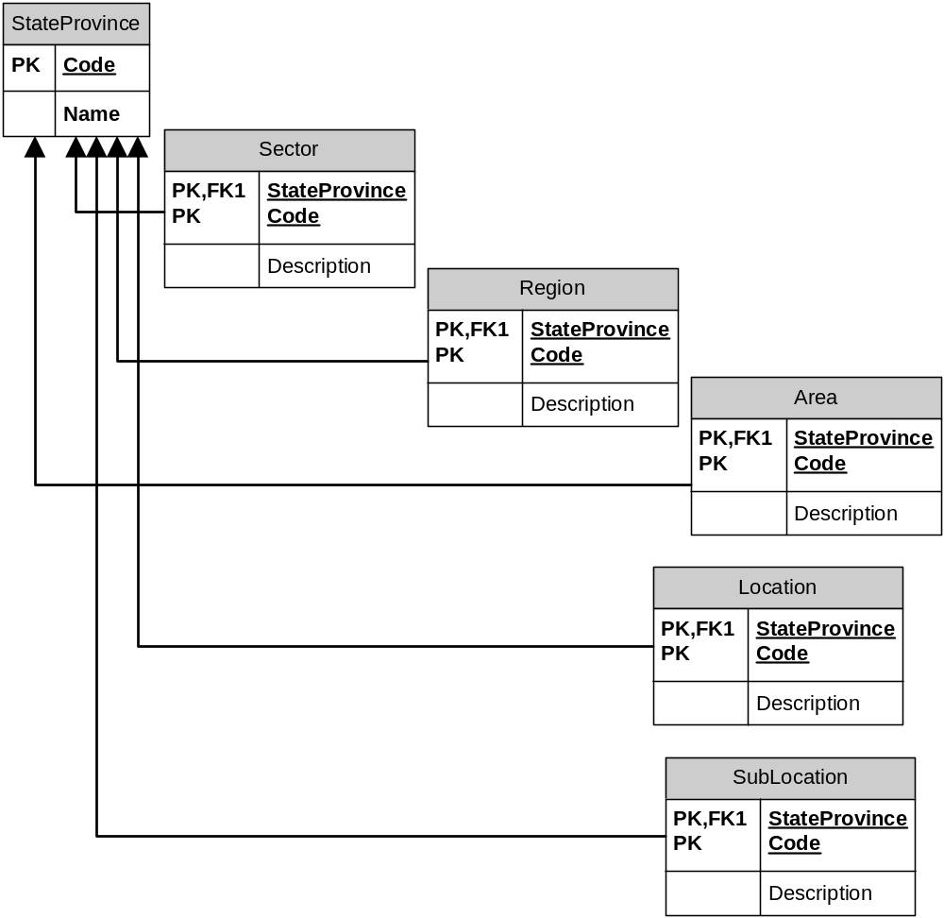
  - CFile Recovery
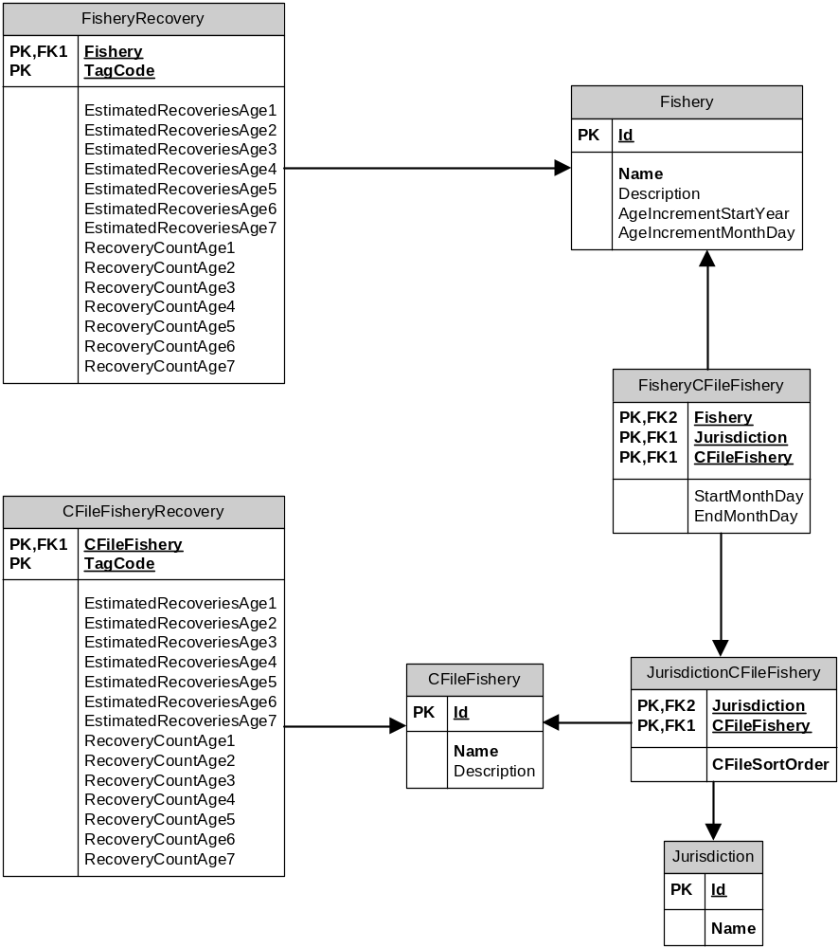

  - Code Tables
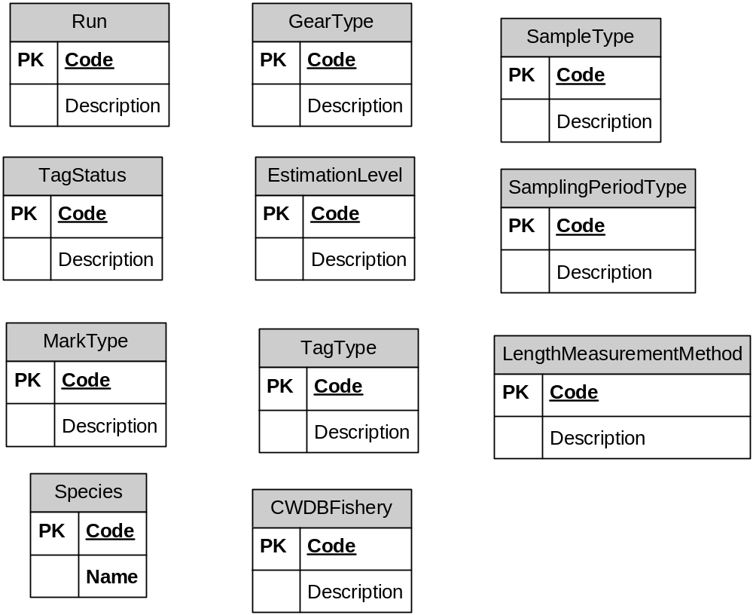
  - CWDBCatchSample
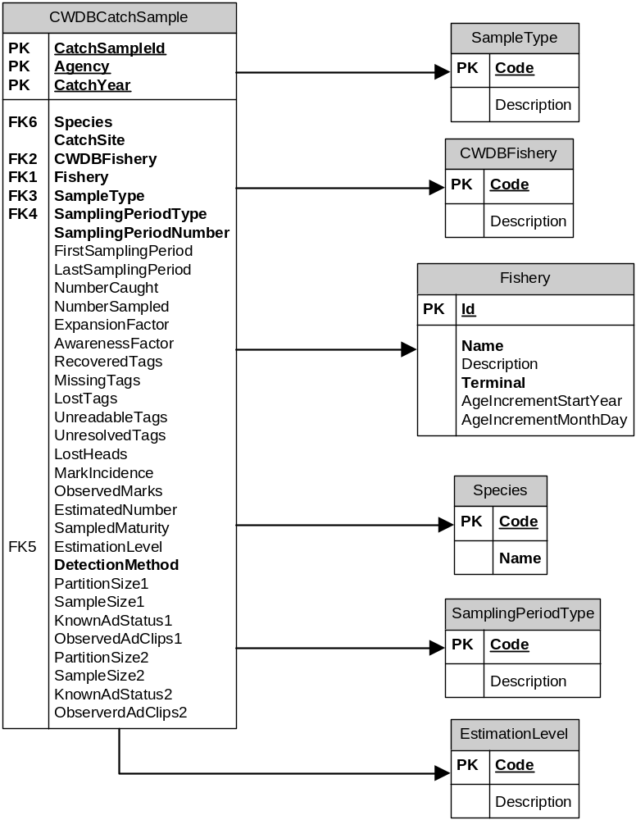
  - CWDBRecovery
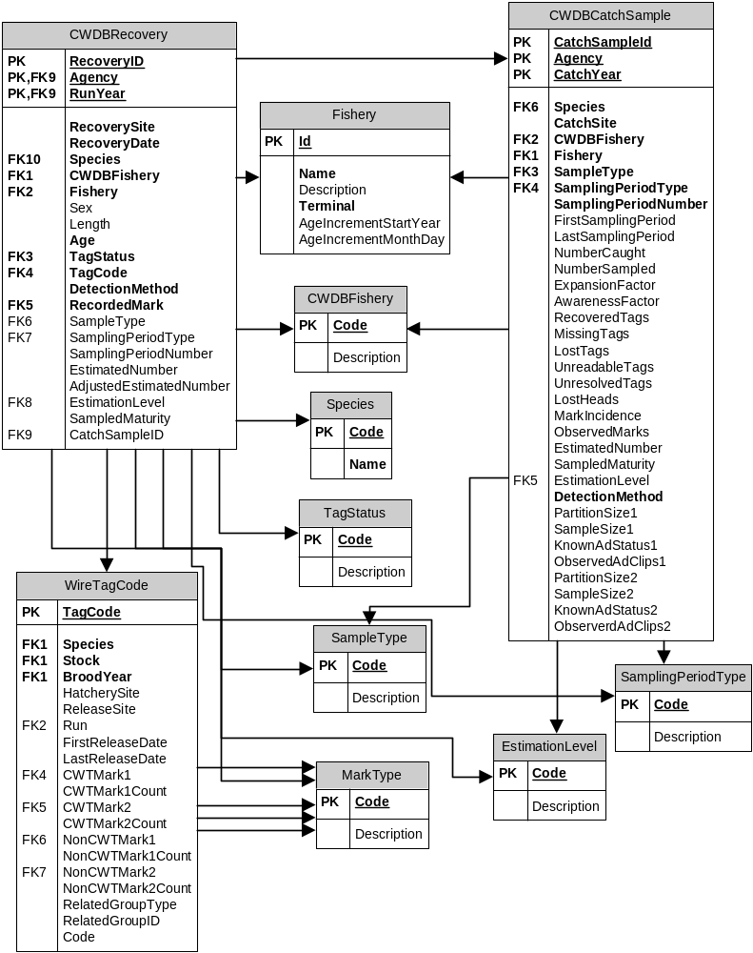
  - Fishery
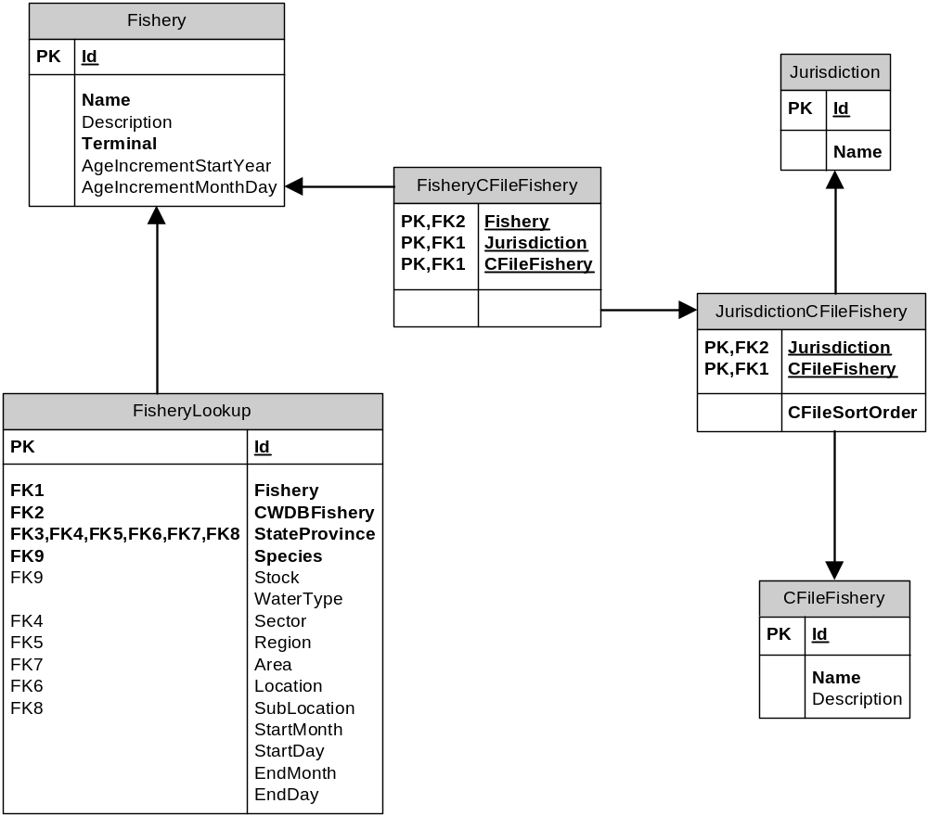
  - StockBrood
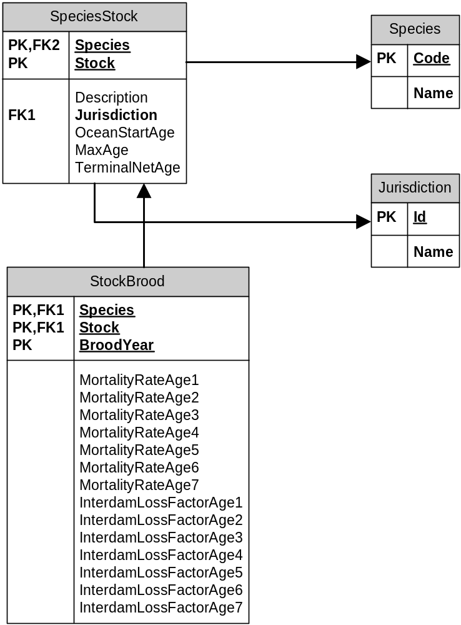
  - AKTrollSportChinookCatch
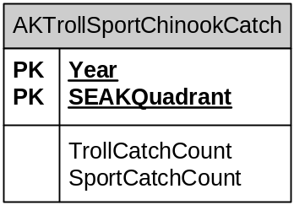
  - WireTagCode
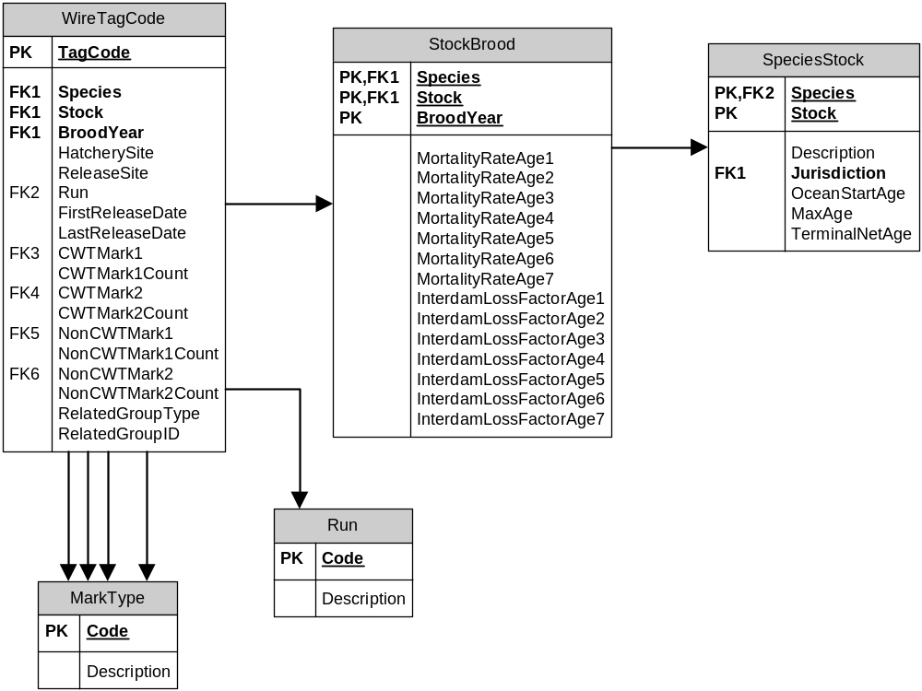

  - RecoveryAge
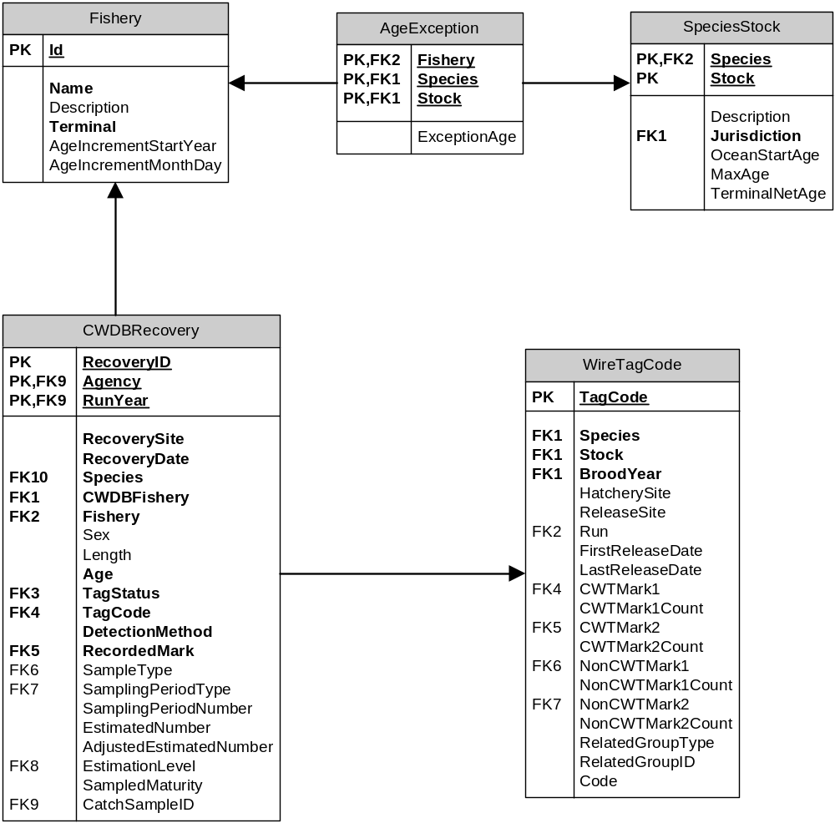

  - Expansions
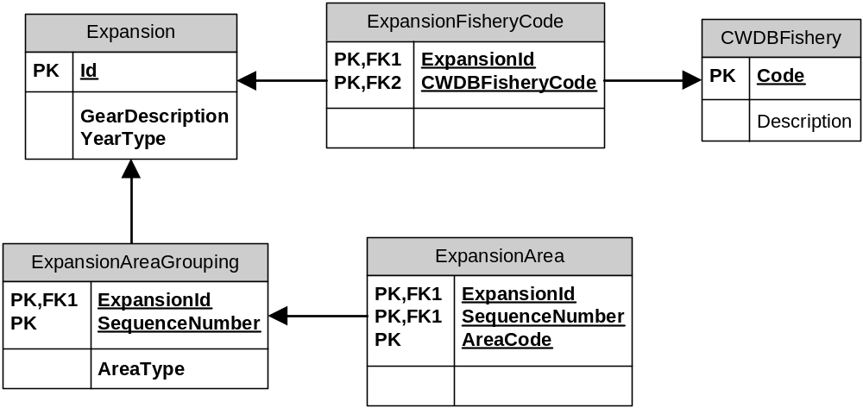

226 Seward St.
Suite 210
Juneau, AK 99801
Phone: (907) 586-6167

Fax: (907) 586-2996


